[H1] Benefits
Dek: The advantages and opportunities of the internet of things.
[H2] IoT can make data easier to access and understand
Internet of things (IoT) applications typically increase the amount and quality of information an organization has access to. Most of the technology’s benefits are based on that fundamental boost in gathering, sharing, and processing data. In some cases, easier access to data is its own advantage—for example, when an organization uses networks of sensors and other IoT devices to better understand what’s happening in distant or hard-to-reach locations.

Industrial manufacturer Siemens used IoT for just this advantage when it remotely tested and started up one of the largest desalination plants in the Middle East. Like many modern IoT applications, this involved creating a digital twin, a virtual representation of a physical object, system, or process. IoT and digital twin applications are often related, as many digital twins use sensors and IoT networks to capture their physical counterpart’s current state in order to digitally mirror it. Siemens’ digital twin of the desalination plant was based on real-time data from the facility, such as current water pressure and flow rates. This data also enabled the company to create a virtual environment for training plant operators remotely. Such applications can be helpful for minimizing travel time and costs and reducing the number of staff needed on-site.

IoT devices can also enhance digital twins with precise, real-time data. Norwegian electrical grid operator Tensio installed IoT sensors from Heimdall Power on overhead power lines to monitor ice, vibrations, and electrical loads. By feeding the location of sensors and their wirelessly transmitted data into a digital twin, grid operators can better assess how close specific power lines are to reaching their maximum capacity.
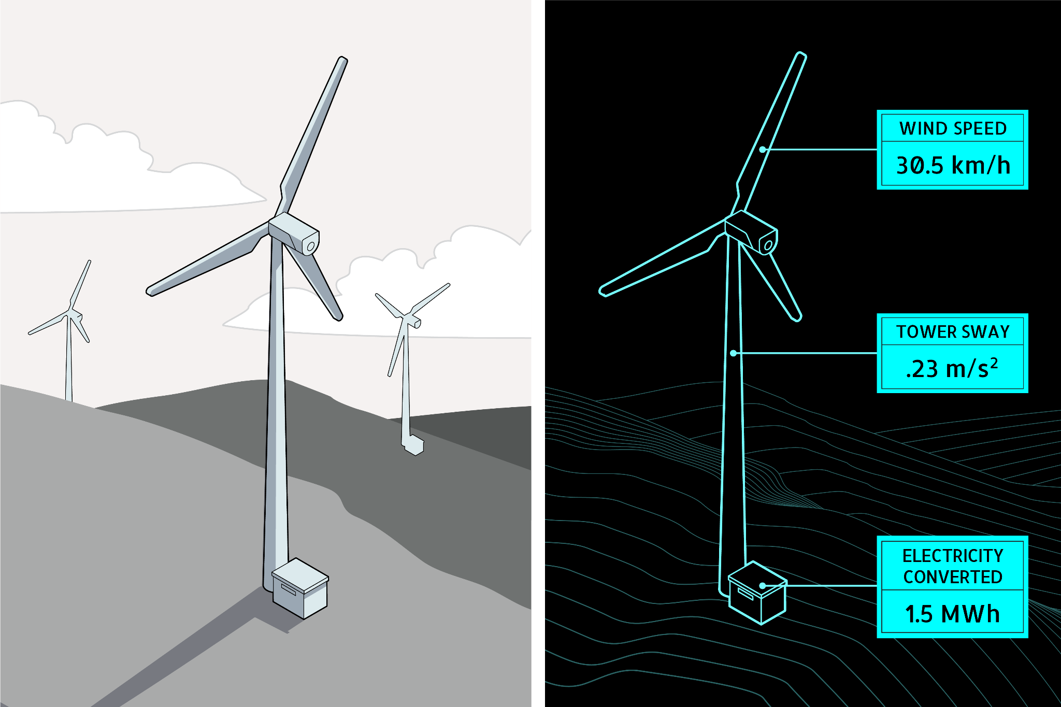
Caption: Most digital twins use data from their counterparts to reflect important physical changes. A twin designed for real-time monitoring of a wind turbine (right) could present its counterpart’s current status as a detailed 3D model (left).

For more about digital twins and their overlap with IoT, see How Digital Twins Work.

[H2] IoT can streamline complex processes
IoT can make processes more streamlined and efficient. Sometimes the result is greater convenience, such as when someone can tell their smart speaker to dim the lights, rather than walk over to the switch on the wall. But the streamlining can be more significant for complex processes across a large business or organization. This is particularly true in large-scale industrial applications.
For example, Airbus, the largest aircraft manufacturer in the world, uses IoT to build its planes more efficiently. In its factories, the company has embedded cameras in power tools and connected them to a wireless network. These tools transmit images of aircraft components to software that identifies the part, finds the ideal amount of torque needed to bolt it into place, and sends that information back to the tool. Although humans are moving these connected tools into place, it’s the larger IoT network that determines how much force to apply. Previously, workers had to check manuals—on either paper or tablets—to find the recommended torque for a specific component and location before using their tools. This was inefficient: Assembling a single aircraft typically requires tightening as many as 400,000 bolts and screws, and in 2019 Airbus delivered 863 planes to customers. It also meant costly risks. “Even a single location being tightened down incorrectly could cost hundreds of thousands of dollars in the long run,” Sébastien Boria, head of R&D mechatronics at Airbus, says. Although Airbus has not assigned a dollar value to how much its IoT system has saved the company, it estimates that smart tools have improved its manufacturing efficiency by 20–30%.
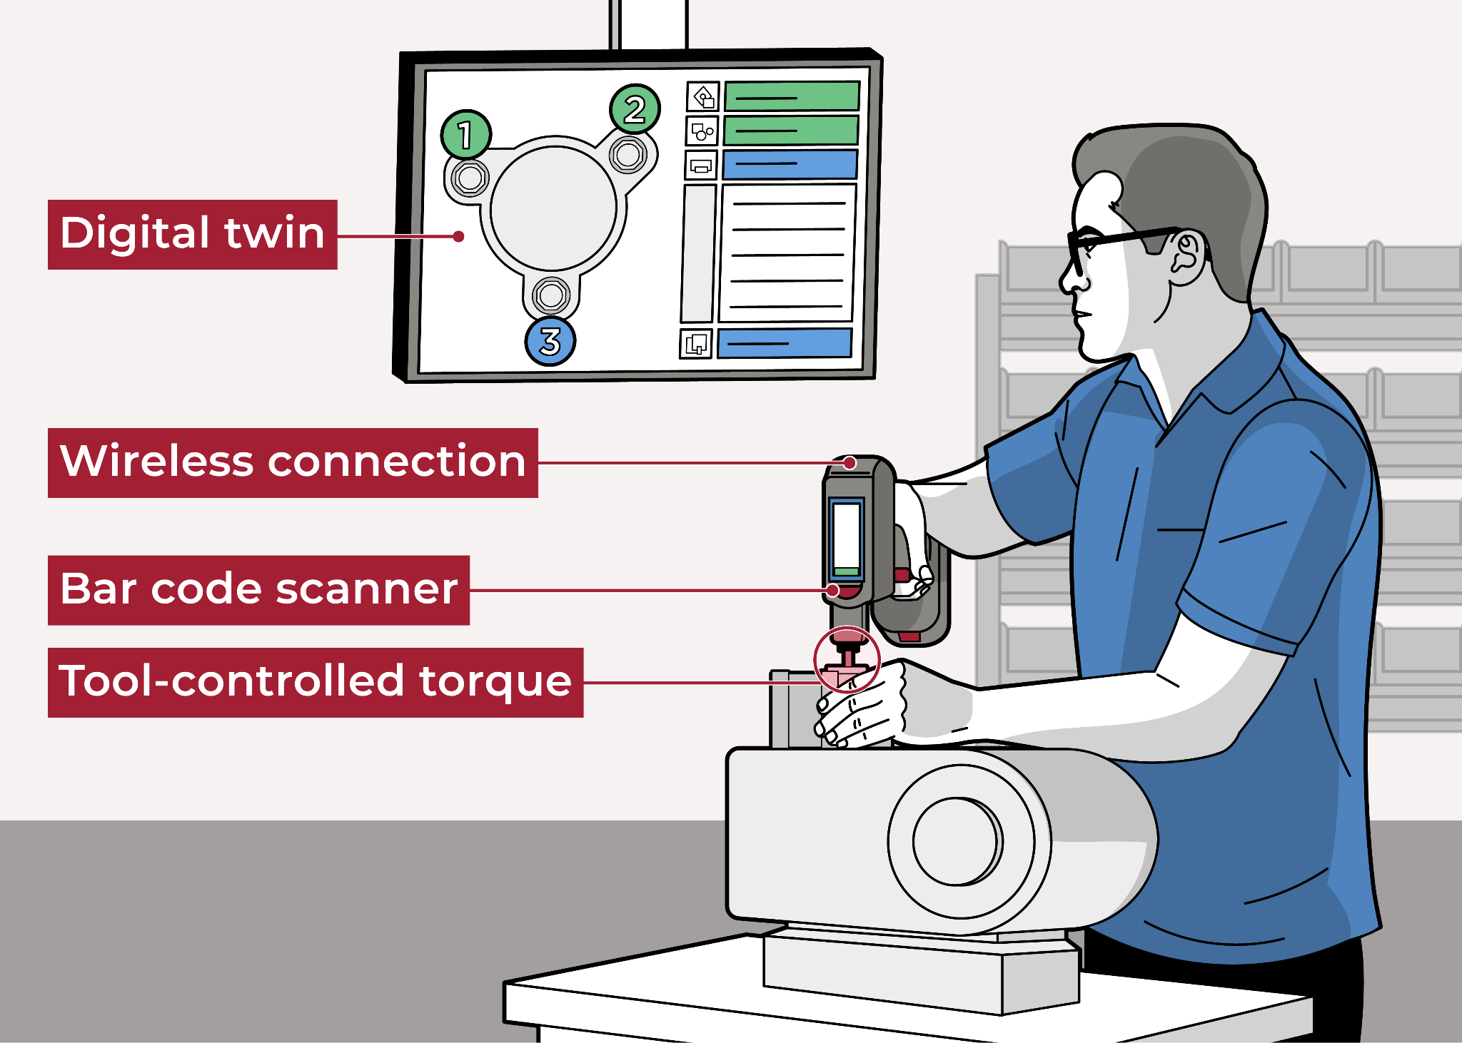
Caption: In applications where under- or over-tightening bolts and other fasteners could pose major problems, connected tools can detect the specific part and location where the fastener is going, automatically adjust the torque, and log the results in a digital twin of the product—such as an aircraft—as it’s assembled.

The company’s IoT system also uses information from connected tools to create a detailed record of how and when they were used. The result is a more detailed and automated version of traditional manufacturing logs, with data that managers can compare and review to make strategic business decisions, such as how best to speed up specific steps in the assembly process.
[H2] IoT can improve sustainability
By making applications more efficient, IoT processes can help improve sustainability. In an analysis of more than 640 IoT deployments worldwide, the World Economic Forum found that 84% of those applications were either addressing or had the potential to address sustainability development goals laid out by the United Nations, such as increasing access to clean water. More than a fifth of the deployments provided an energy-related benefit, including conserving electricity. “In many cases it wasn’t that organizations specifically aimed to decrease energy consumption,” Jeff Merritt, the head of IoT, Robotics, and Smart Cities at the World Economic Forum told MIT Horizon. “Using the IoT to conserve energy just makes good financial sense.”
Bosch, a multinational engineering and electronics company, has installed IoT monitoring systems to save energy in more than 100 of its 400 locations. At its plant in Homburg, Germany—one of Bosch’s largest, at which it manufactures engine components for industrial vehicles such as tractors—the company uses a proprietary IoT application called the Energy Platform to analyze data from sensors on all 3,600 of the plant’s machines. This enables a wide range of energy-saving measures, including spotting machines that are using excess power because of a malfunction, such as a leak in an air compressor. The IoT system also provides managers with detailed data about when machines are typically used and gives them the ability to remotely shut down specific machines in the network. Before installing the Energy Platform, plant managers often left unused machines in standby mode, which made them readily available but consumed more electricity than powering them down. At the Homburg plant alone, Bosch estimates the Energy Platform saves more than $2.8 million in energy costs and 5,000 tons of carbon dioxide emissions per year, contributing to the company’s ability to keep carbon neutral.

AT&T also uses IoT to reduce its global footprint. The company has installed IoT lighting and HVAC systems across 240 of its facilities, or 20 million square feet of property. The retrofit project, which is a partnership with Enlighted, a Siemens company, includes installing networks of wireless sensors in each building’s light fixtures. These sensors measure light, temperature, and motion 65 times per second within their immediate area, providing more precise readings than what’s taken by traditional room- or floor-wide sensors. Enlighted’s constant flow of wireless sensor data allows a building’s computer-controlled lighting and HVAC systems to respond quickly, and in a targeted way, such as turning off lights and heat when an area becomes unoccupied, or starting to cool an area that’s suddenly crowded with people before the ambient temperature spikes. The data can also feed software that produces long-term analyses of how people are using an entire facility at different times, giving building managers insights into how they might reconfigure work spaces to further optimize energy use.
The partnership with Enlighted for IoT heating and lighting control is part of an ongoing effort at AT&T to make all its facilities more energy efficient. The company estimates that once it optimizes lighting and heating across all 120 million square feet of its property, its energy use will be cut by 195 gigawatt-hours, which is enough electricity to power more than 18,000 homes in the U.S. for a year. AT&T also estimates that its IoT upgrades could save the company $200 million over a 10-year period.
For more about how organizations use IoT to pursue sustainability goals, see Opportunities in IoT for Sustainability.
[H2] IoT can detect problems early, reducing their harm
IoT sensors can gather information and communicate warnings about problems ahead. Occasionally these are urgent emergency alerts, such as a warning from sensors in an aircraft engine to the ground crew about a component that’s about to fail. But many warning systems collect, share, and act on sensor data related to smaller, accumulating problems. Manos Tentzeris, an IEEE fellow and professor at Georgia Tech’s School of Electrical and Computer Engineering, tells MIT Horizon, “With the IoT you’re able to monitor at the level of nuts and bolts, which is impossible to do with conventional approaches.” Doing this can produce alerts further in advance, before costly maintenance is needed or dangerous emergencies arise.
The mining company Rio Tinto, for example, uses IoT to quickly detect problems in thousands of its self-driving mining vehicles. Rio Tinto’s trucks are embedded with a range of wireless sensors, including 30 in each of their tires. The vehicles have GPS sensors that record geographic location and also temperature, vibration, and ultrasound sensors that provide performance and maintenance-related data. The sensors send this data to a central control station where artificial intelligence software analyzes it, comparing data with previous readings and with data from other trucks to spot anything out of place, such as parts that might be wearing down before the vehicle’s next scheduled maintenance. “Some software can detect signals and data that even a sophisticated engineer might not catch on their own,” Lila Fridley, a senior product manager at Splunk, a data analytics company, tells MIT Horizon.

In Rio Tinto’s case, company engineers can closely review the sensor data from “haul trucks” to determine which ones require hands-on inspection or maintenance to avoid a failure that takes the truck out of commission. Those breakdowns are costly: The company estimates that each time one of its massive, two-story-tall trucks breaks down, it costs the company $2 million per day. It also estimates that in a typical year each of its IoT-connected trucks runs for 700 hours more than a traditional truck. Some of that increased productivity has to do with robotic navigation, not just IoT sensors. But Rio Tinto considers IoT a major reason for the trucks’ productivity. It also says that using IoT to guide maintenance reduced the company’s costs for loading and hauling by 15%.
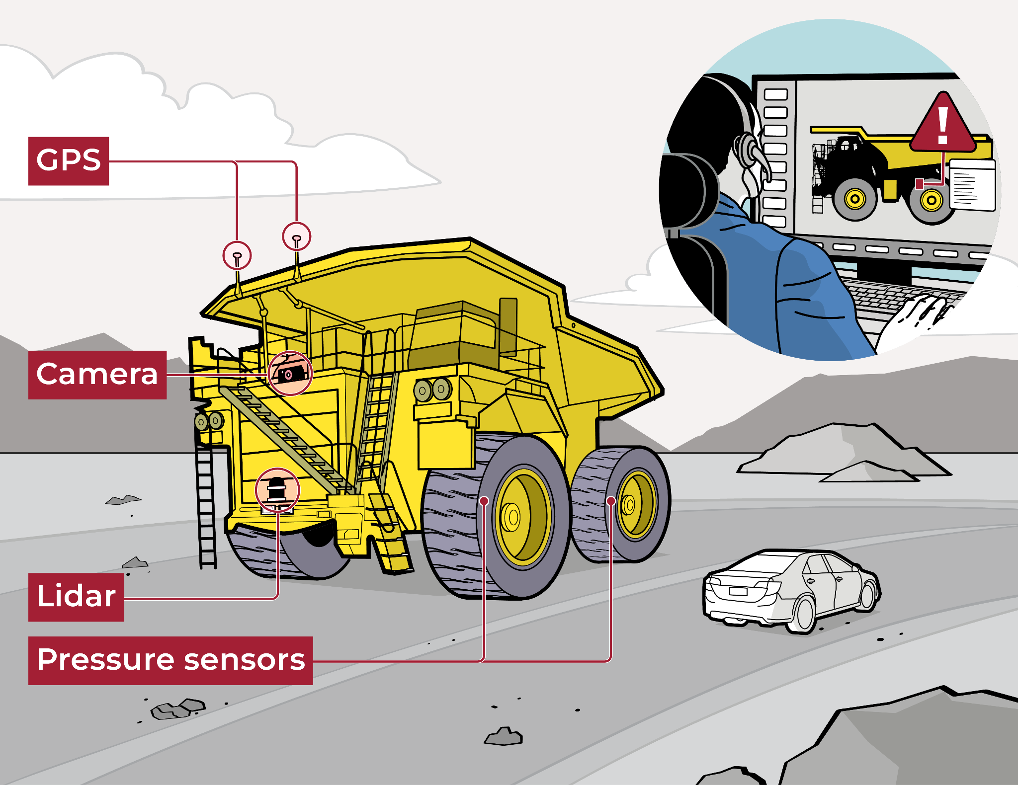
Caption: Massive self-driving haul trucks use cameras and lidar—sensors that bounce lasers off nearby objects—to navigate while sending their GPS position and tire pressure to remote operators. This flow of sensor data lets mining companies address maintenance issues before they escalate to breakdowns.
Early-warning IoT applications are also beneficial in medicine. For example, measuring blood glucose levels allows diabetic people and their doctors to recognize early signs of, and avoid, diabetic shock and other serious complications. Historically, such measurement has required the person to prick their own finger multiple times a day—which is uncomfortable, requires proper testing equipment, and provides only readings that are hours apart. An improvement on this strategy comes from continuous glucose monitoring systems such as the Dexcom G6 and FreeStyle Libre, which use an adhesive patch with a small needle that sits just under the patient’s skin. Although they are not usually marketed with this language, these systems are IoT applications: The patch contains a sensor that takes a reading either on demand or automatically as often as every five minutes. The system wirelessly transmits that data to the patient’s phone or to a dedicated device for displaying results, providing alerts when levels are notably high or low.
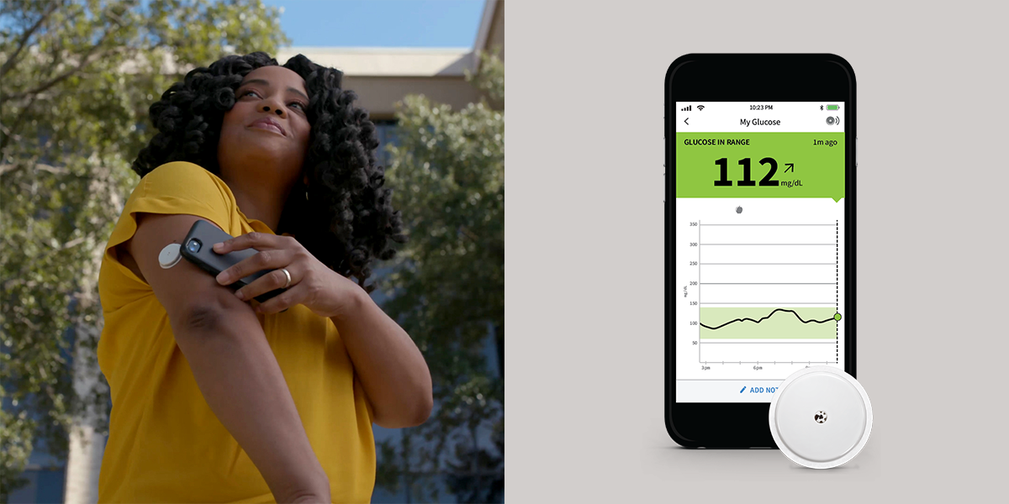
Caption: The Freestyle Libre 2 is a wireless sensor that continuously monitors the wearer’s glucose levels. The device uses an NFC connection to send detailed data to the user’s phone when the phone is brought close to the sensor and a Bluetooth connection to send alerts. FreeStyle Libre. ©Abbott 2021. Used with permission.
By using IoT to access their current glucose levels almost constantly and with less pain, as opposed to pricking their finger for each reading, users are more aware of changes in their blood sugar throughout the day. This has been shown to improve their ability to use food or medications to keep their glucose levels within the recommended range, where complications are less likely to occur. In a 2020 study, more than 12,000 participants were given FreeStyle Libre systems, whose adhesive sensor patches remain attached for up to two weeks at a time. Use of this system reduced acute diabetes complications, such as diminished liver and kidney function or becoming comatose, by about half for people with type 1 or 2 diabetes.
The capacity of IoT to detect problems early and noninvasively, using wireless communication to alert physicians and avert serious medical problems, has led to a growing range of medical applications in addition to diabetes monitoring. Handheld wireless scanners can detect the early signs of bedsores: When held against areas where bedsores tend to occur (such as a patient’s heel), the scanner quickly measures the amount of moisture building up below the skin. By displaying this information—which is difficult to spot with a visual check—the scanner enables nurses and doctors to take action to prevent a wound from developing.
Another application, used at the Rancho Los Amigos National Rehabilitation Center in Southern California, is a special IoT boot that allows doctors to measure how much pressure is being applied to different parts of a person’s foot as they walk. The constant stream of data transmitted by sensors in the boot allows doctors to study how a diabetic patient is moving and helps lower their risk of developing the kinds of serious ulcers that can lead to amputation.

[H3] Learn more
- Common misconceptions about IoT
- Recent developments in IoT
- How IoT is used today in industry

